# Project Management Concepts

Obsah

Project Management Concepts 1

Project Management Concepts 2

Project Lifecycle 2

Project Governance 2

Business case 3

Project manager 3

SKILLS 3

Types of Project Organizations 4

Choosing and prioritizing projects 4

After choosing 5

Project requirements 6

Key documents (during conceptualization phase) 6

Stakeholders 6

Project planning 7

Project Scheduling 8

Communication plan 10

Risk management 11

Risk register 12

Procurement Management 13

Project implementation 13

Start-up meeting (kick-off) 13

Tracking and control 15

Project documentation management 15

Project closeout 16

Lesson learned 17

Project Leadership Skills 18

Maslow’s pyramid 19

Herzberg Hygiene-Motivation Theory 20

Body language 21

Shannon-Weaver model 22

Main causes of communication breakdown 23

Miscellaneous 24

# Project Management Concepts

* Vision, design, strategy and execution
* <https://www.amazon.com/Project-Management-Concepts-Techniques-International/dp/1466502886>

#### Project

* **A temporary endeavor undertaken to create unique product or service**
* Temporary
* Have sponsor (stakeholders, interested parties …)
* Can include smaller project as well

#### Project portfolio

* A projects and programs together to facilitate strategic business objectives

#### Program

* A group of related project which are more useful to manage them together

### Project Lifecycle

* Engineering V - from abstraction to low-end and then back
* Waterfall
* Incremental model
* Prototype

### Project Governance

* Relationship between all internal and external groups involved in the project
* Approval and direction for a project
* Identified stakeholders
* Agreement on a deliverable
* Processes to manage risk, issues, scope …

## Business case

Has to include at least this:

1. The business problem
2. Details of the project’s fit with organization's mission
3. Expected benefits to the organization
4. Cost/benefit analysis
5. Funding and its sources

**Triple constraint**

Quality <-> Scope

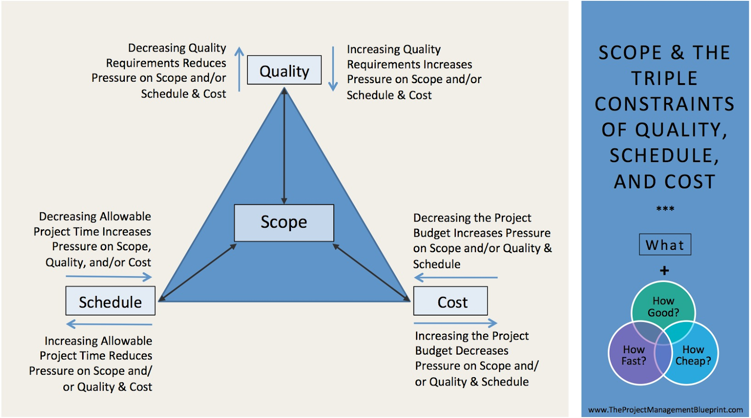

## Project manager

### SKILLS

1. Organization and managements
2. Technical
3. People and Communication
   1. Support, motivate, decide, inspire, challenge bad decision of CXO
4. Administration
   1. Monitor, analyze, cash flow, HR

Notes

* Be aware of micromanaging of technical stuff
* **Manages, prioritizes … according business needs**
* Open communication with sponsors
* Link between users and external providers

Knowledge area

* Time, Scope, Cost, Quality, HR, Communication, Risk, Verejne zakazky

Business case -> **Proposed solution**

* Business opportunity
* Market analysis
* Assumption and constraint
* Other alternatives - we can choose already built system
* Benefit and cost
* Mitigation of risk and risk management
* **SUMMARY**

### Types of Project Organizations

1. Functional - to get specialist we need to ask head of his department
   1. 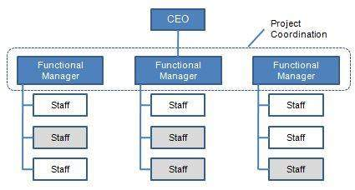
2. Project-based - bigger teams, no need to ask for help from other department, higher cost and less productive for short-lasting projects
   1. 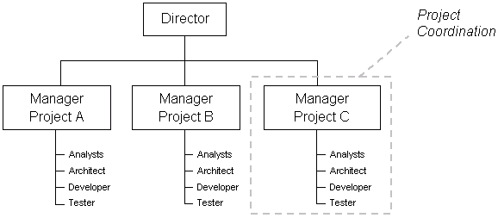
3. Matrix - sharing information, better reassign of people, more complex (assignment’s conflicts)
   1. 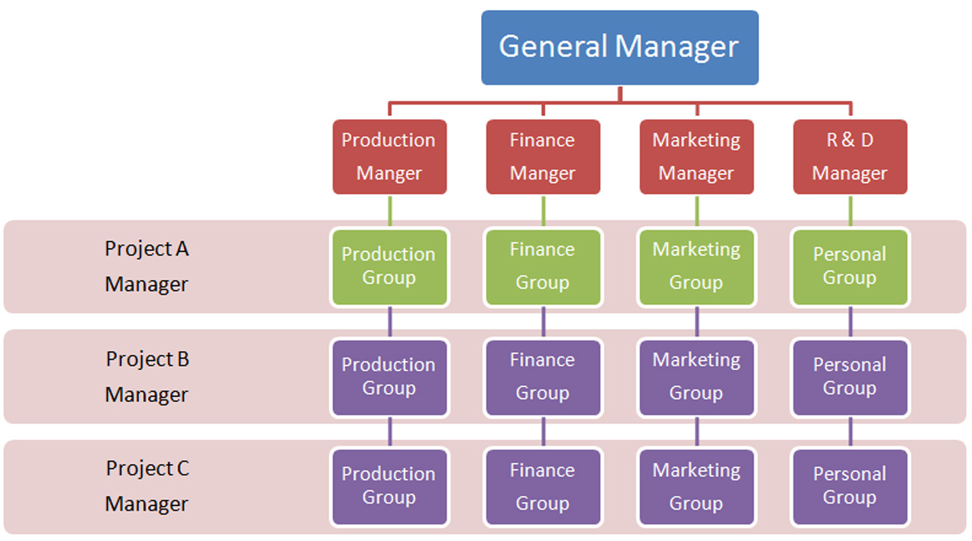

### Choosing and prioritizing projects

* Benefit-cost ratio
  + Graph
    - Cumulative cost of ownership + operations
    - Cumulative benefits/revenue
* Internal rate of return
* Payback period
  + Break-even point in time
* Return of investment
  + ROI = (cumulative benefit - cumulative cost) / cumulative cost

**Present Value** - Value on a given date discounted by time and other factors (fee, risk …)

* Present value = FV / (1 + r)^n
* Where: FV = future value, r = interest rate (0.05), n = number of periods

**Net present value** - PV input cash flow - PV output cash flow

* https://lh4.googleusercontent.com/_OrLiZ7PzV8WauVS8wGWLmgmrhRqY_xWd8WWLJRv4ucnblGsbJoznnizZbgG9kZbRaAqASazAQDCWcs9qdsQOvm7MJekdwiXwJs1rgQWlivvb0JOsG4-s9YcplzM0J5-z30xMyAZ
  + Ct = net cash inflow during the period t
  + Co = total initial investment costs
  + r = discount rate, and
  + t = number of time periods
* To determine if the investment does make sense after predicting cash flow and the price for that item

### After choosing

* **Project charter**
  + Sign by managements and sponsor to support the project initiation stage
  + 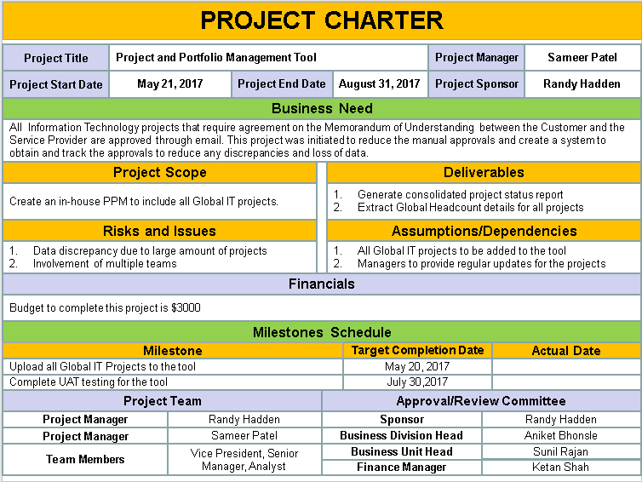
* **Kick-Off meeting**
  + Discuss project vision, meeting of all parties
* **Launch project**

## Project requirements

**Scope management**

* What to do and nothing else
* Statement, description, definition, specification, scope of work

### Key documents (during conceptualization phase)

* Needs assessment
  + Record of the stakeholder needs that motivate the development of the project
* Functional requirements
  + What the product/service will perform, how well it help the operational environment
* Solution design
  + Architecture, components, modules ...

## Stakeholders

* People directly/indirectly and positively/negatively affected by a project
* 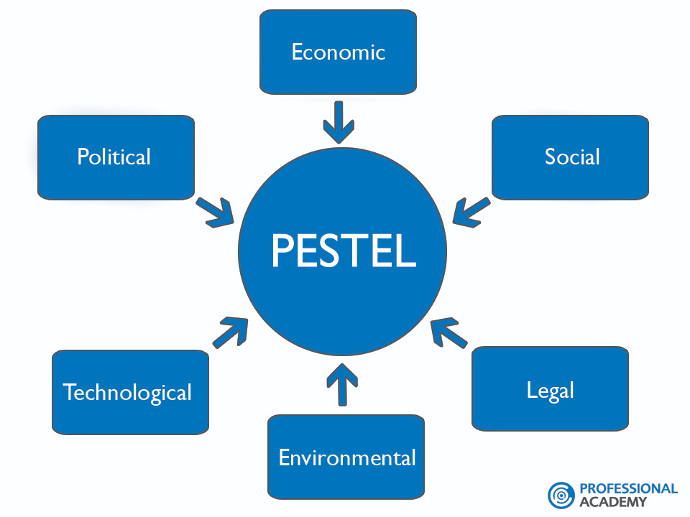
* Analysis
  + Identify project stakeholders
  + Identify stakeholders’ interests
    - Lead to document
  + Access stakeholders for importance and influence
    - For example scale from 1 to 5
  + Outline assumptions and risks
    - Communication plan (frequency, topic …)
  + Define stakeholder participation

## Project planning

Output: project plan to be presented to management

* Set the environment - Organization breakdown, Scope specification, Quality plan, Life cycle
* **Estimating of project activities and durations (+ linkage between them)**
* 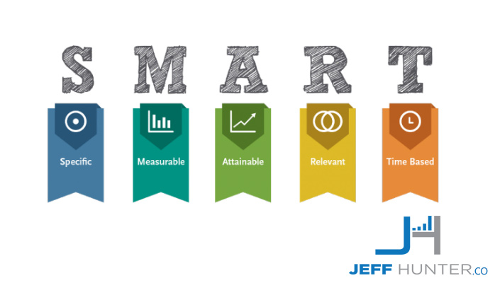
* 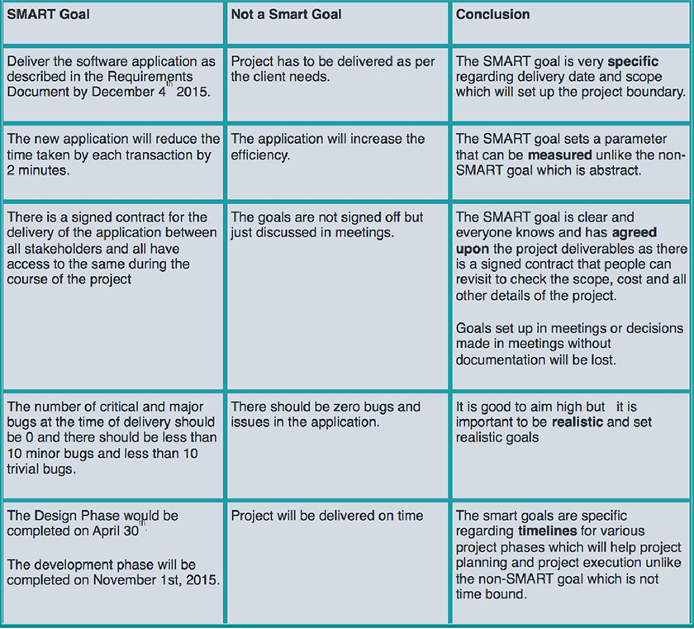

#### Work breakdown Structure

* + Tree structure
  + To certain granuality
  + Human/Material/Equipment resources
* GAP analysis
  + **Get** - get information to get from unknown to known (measure, ask ..)
  + **Assume** - assume to get information based on known data
  + **Park** - No way to make assumption so we park them to 2 field (postponed, abandoned)

### Project Scheduling

#### Gantt chart

* 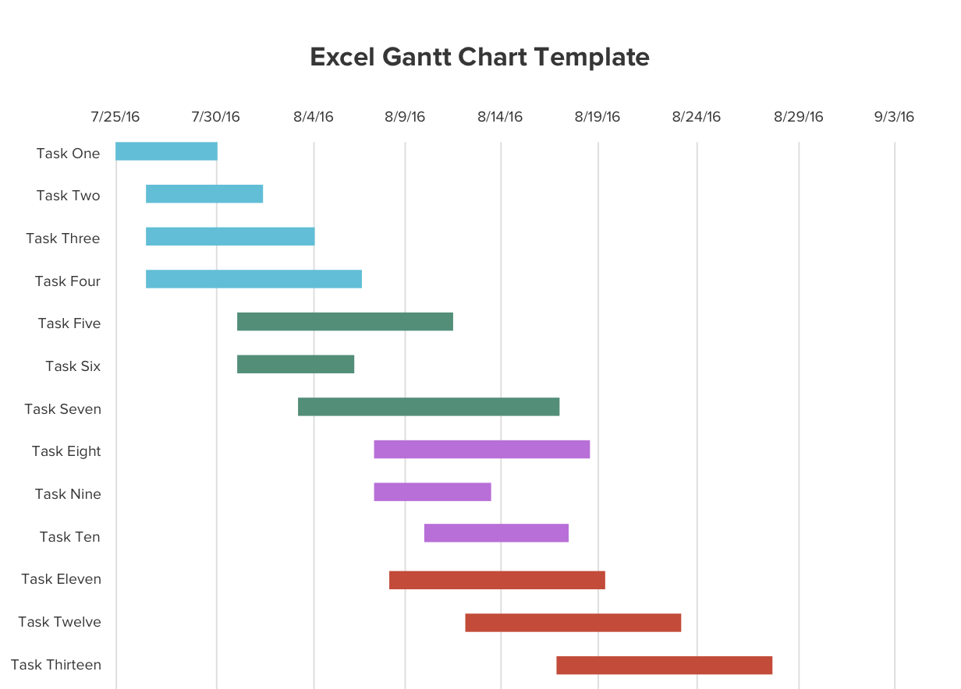
* From **Work breakdown structure**
* 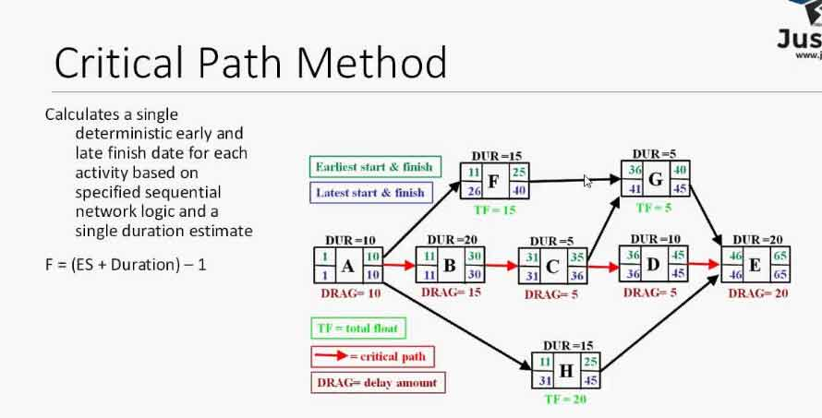
  + **Earliest from the beginning**
  + **Latest from the end**
* 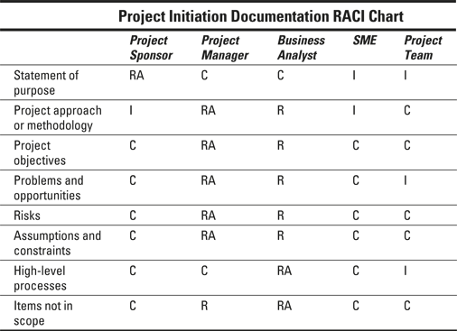
  + R (Responsible)
    - The person who does the work to complete the task or make a decision. Several people could be responsible for one task but each task should have at least one responsible person.
  + A (Accountable)
    - The person who is accountable for the correct and on-time fulfillment of the task. Ordinarily this person should sign off or approve the task. Only one person should be assigned per task.
  + C (Consulted)
    - The person who provides the information for the project before the task can be done or approved. It could be one or several people and is assignment into this group is optional.
  + I (Informed)
    - The person who need to be informed about task progress. That person could be affected by the outcomes of the task and for this reason should be informed, but isn’t the consultant and does not contribute to the task completion. It could be one or several people and their assignment into this group is optional.

### Communication plan

* 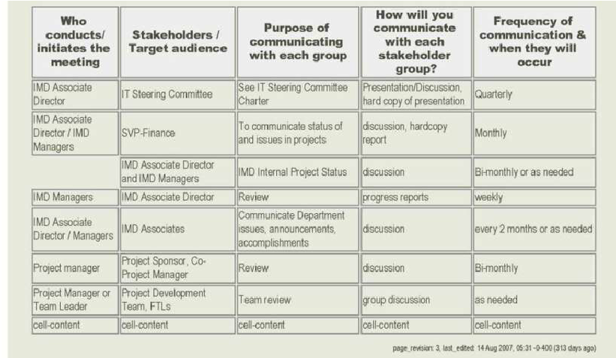
* + type of meeting

## Risk management

* Source from technology, schedule, financial, legal …
* Focus on
  + Assumption of event
  + Event
  + Threats/impact of event
  + Cost
  + Probability
* 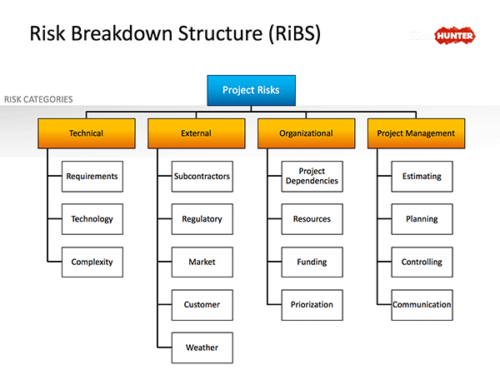

### Risk register

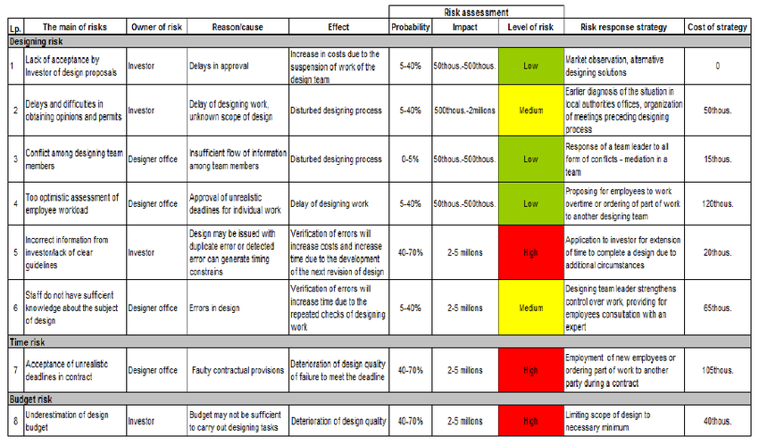

* Techniques to identify risk
  + Checklist
  + Brainstorming
  + Nominal group technique
    - Like brainstorming but write down and read one after another in a circle (not affecting other with opinion)
  + Based on similar projects
* Ranking by Paired analysis
  + Small groups of people and small groups of problem

## Procurement Management

* Verejna zakazka
* Make-or-buy decision (price to develop in-house in contrast with buy from other firm)

## Project implementation

### Start-up meeting (kick-off)

* + **Meeting Objectives**: What do we want to achieve at the end of this meeting.
  + **Project Objectives**: What do we want to achieve at the end of this project.
  + **Project Approach**: Define the main phases or components of the project, what is expected during the project, are we following a specific methodology?
  + **Deliverables**: Discuss and document what are the expected deliverables of the project so that there are no misunderstandings on what will be produced.
  + **Project Team**: You might want to create and organization chart of your project, including main stakeholders, steering committee members, subject matter experts and technical resources that will be participating in the project.
  + **Roles & Responsibilities**: It is also a good idea to define the main responsibilities of each role in the project team. This will help to set expectations from the very beginning.
  + **Change Control**: Define the process that will be used to manage change, especially scope change.
  + **Communication Plan**: Define how the project communication will be done: Status Reports, frequency of meetings, project portal, etc.
  + **Risks**: Identify the main potential project risks. This should be handled as a mini risk assessment session.
  + **High-level Requirements**: This is a very important part of the meeting, since you can collect a high-level description of each requirement, usually in a few lines per requirement. It is important to identify each requirement with an identification number or ID, and if possible with a priority indicator, like high, medium, low. I have successfully used a PowerPoint table to capture requirements during the meeting so that everybody can see them when projected on a large screen.
  + **Timeline**: Discuss a tentative timeline for the project, but be sure to let everybody know that the timeline will need to be validated once the detailed project schedule is completed.
* Focus on
  + Team recognition and reward
  + Team building activities
* Change management

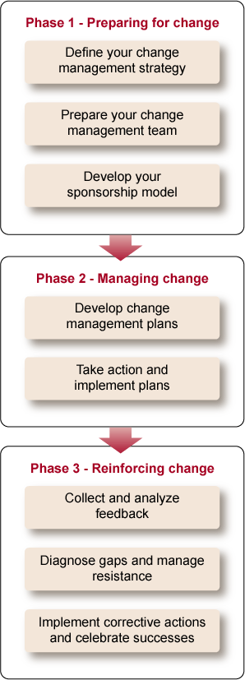

* + Scope, Change request, Change control, Change management, Change program
    - Record change request (document)
    - Change impact evaluation
    - Change impact proposal
    - Change request proposal
    - Change request implementation
    - Project plan update

### Tracking and control

* Baseline management
  + Setting baseline criteria (should be SMART)
  + Schedule and budget
* Tracking
  + Reports
  + Stand-ups
  + Duration of tasks
  + Risks
    - Mitigate them?
    - Getting worse?
* Project reporting
  + Status, Meeting notes, progress reports, executive meetings,
  + Forecasting (planned cost)
  + Earned value reporting
    - ability to combine measurements of the project management triangle: scope, time, and costs.
    - A project plan that identifies work to be accomplished
    - A valuation of planned work, called planned value (PV) or budgeted cost of work scheduled (BCWS)
    - Pre-defined "earning rules" (also called metrics) to quantify the accomplishment of work
  + Trend analysis

## Project documentation management

* **Project Schedule:** Typically, project managers use project software to manage their projects' schedules, resources, dependencies, and project costs.
* **Risk Management:** A Risk Management document is used for the purpose of capturing risks by group, category, and it allows you to rank or prioritize your risks. Risks could convert to issues and then block your project from moving forward.
* **Issues Log:** Issues could block your project from moving forward or delay your implementation date. You need to use this document to track your issues to completion.
* **Project Budget:** It is imperative to track your project budget. This document allows you to track all costs associated with your project. Project costs include resources, hardware (servers, computers, etc.), software, and vendors.
* **Communication Plan:** This is a key project document because it proactively communicates to all of your stakeholders your communication media, frequency of communication, and communication content. You do not want your stakeholders guessing about your communication strategy.
* **Project Status Report:** You need to communicate (ideally weekly) your project status to your stakeholders. You should report on progress/accomplishments, risks, issues, and next steps.
* **Project Charter:** This document captures the mutual agreement and initiation of a project. The charter contains a high level schedule, high level assumptions and constraints, and project requirements.
* **Meeting Agenda/Minutes:** Document your formal status meeting. Many organizations have existing meeting templates for you to create your meeting agenda. Meeting attendances have a tendency to be higher when invitees can verify in advance that your meeting will be productive. You should recapture the meeting discussions using your meeting minutes document because it would help to provide clarity after the meeting and/or uncover discrepancies.
* **Quality Assurance (QA) Test Plan:** Reviewing and authorizing your projects' QA document could save time and money later during your project testing phase. The QA document contains the testing strategy, testing tools (automation), high level duration, and number of QA testers.
* **Project Management Plan:** The Project Management Institute (PMI) consolidated nine subsidiary plans (formal project artifacts), which are:

**Acceptance signature**

### Project closeout

* Post-implementation review report
* Measure if KPI are satisfies -> take knowledge if not
* 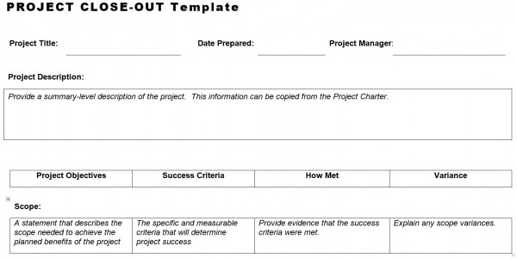
* People management
  + Recognition and awards
  + Performance evaluation
  + Celebration

### Lesson learned

* + 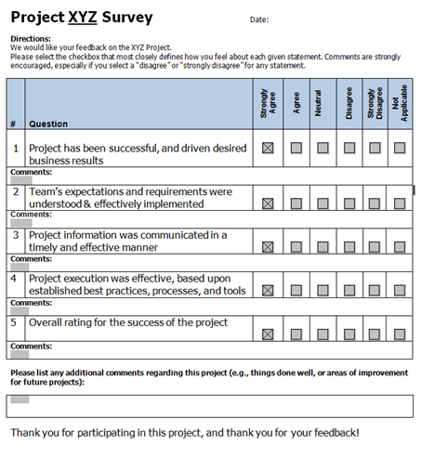

## Project Leadership Skills

* Leadership
  + Do the right thing and communicate it to others
  + Setting direction
  + Inspiring and motivating
  + Aligning people
* Manager
  + Planning
  + Organizing
  + Commanding
  + Coordinating
  + Controlling
* Situational Leadership
  + 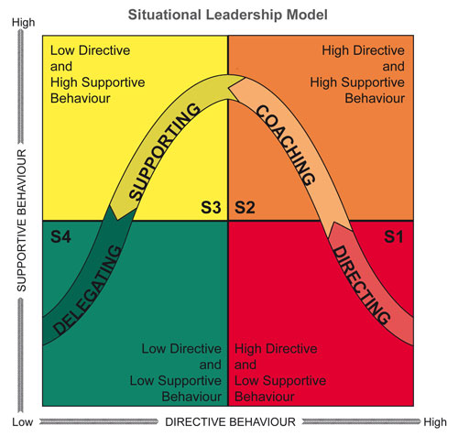
  + Transfer from S1 over S2, S3 to S4

### Maslow’s pyramid

* + 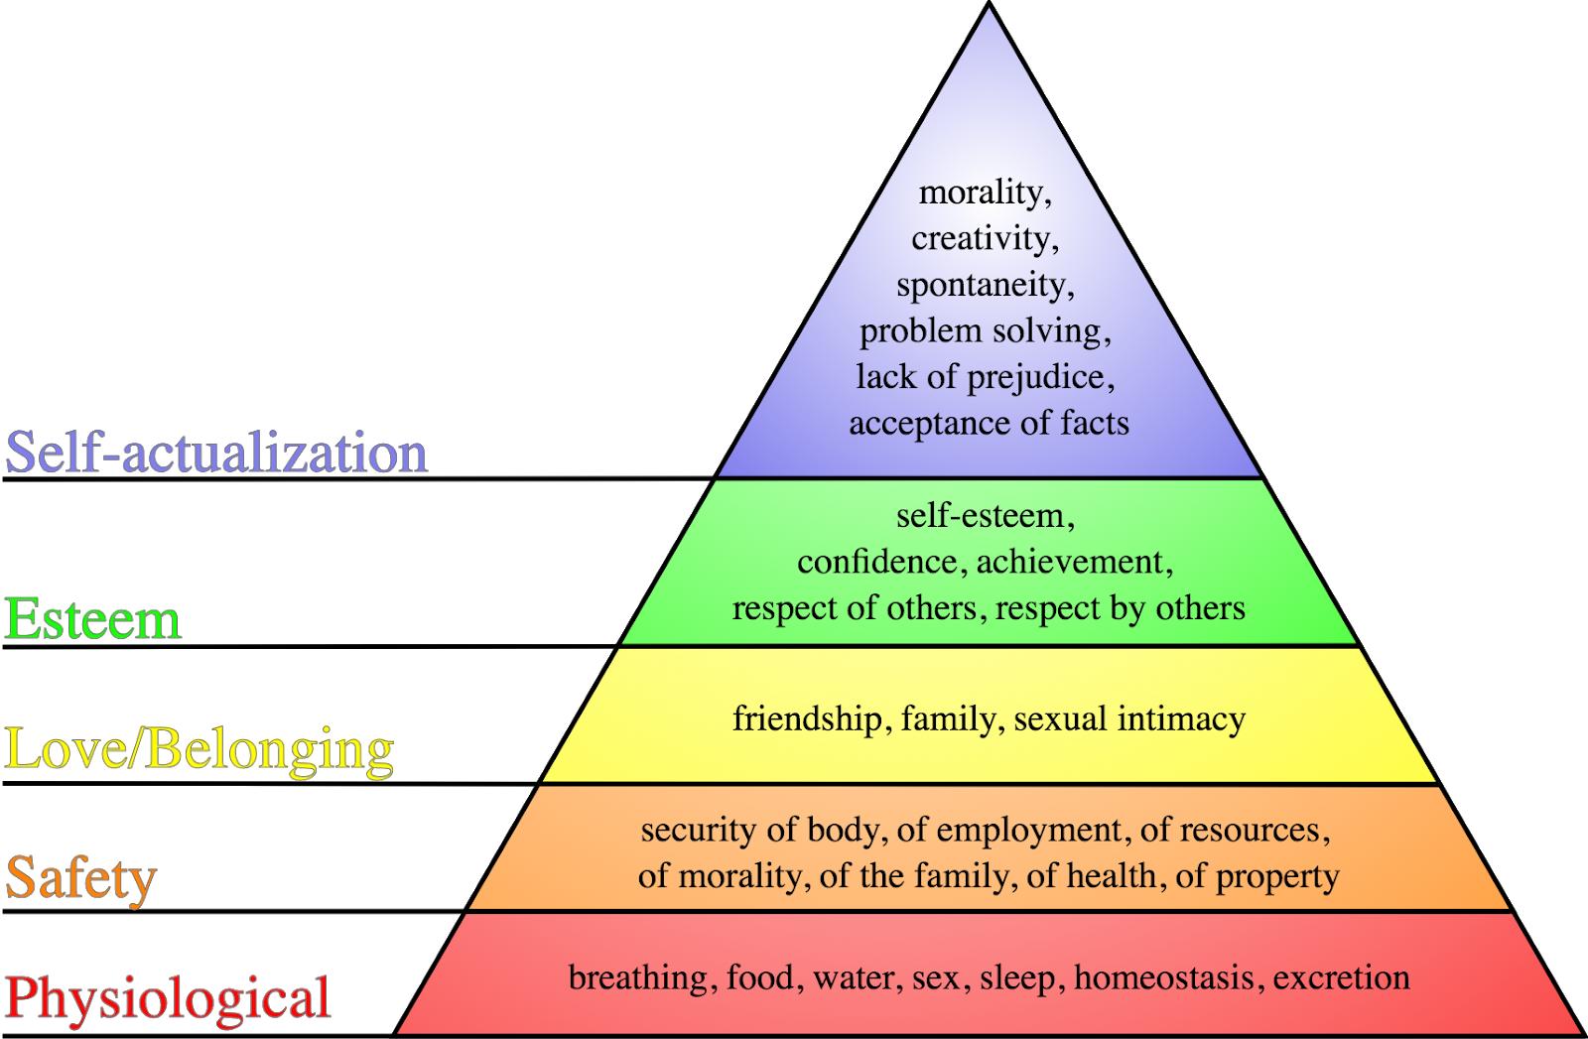
  + Focus on the lower levels before the higher one
  + Help other members of your team with satisfy the lower (while the lower obligatory needs are satisfied, the desired psychological needs can be reached)
    - Lack of physiological is terminal
    - Lack of safety leads to infirmity (physical or mental weakness)
    - Lack of Love/Belonging leads to loneliness and social anxieties
    - Lack of esteem leads to  losing the feel of self-respect, confidence, competence …
    - Self-actualization is not the “essential” but if all lower are satisfied then it can lead to find of your personal purpose, personal growth and realization of their potentials
  + PM can do:
    - Involving person in planning his own work, opportunities for growth
    - Freedom to make a decision and be recognized for them
    - Opportunities to interact with other co-workers
    - Job security
    - Rest period and adequate compensation

### Herzberg Hygiene-Motivation Theory

* + 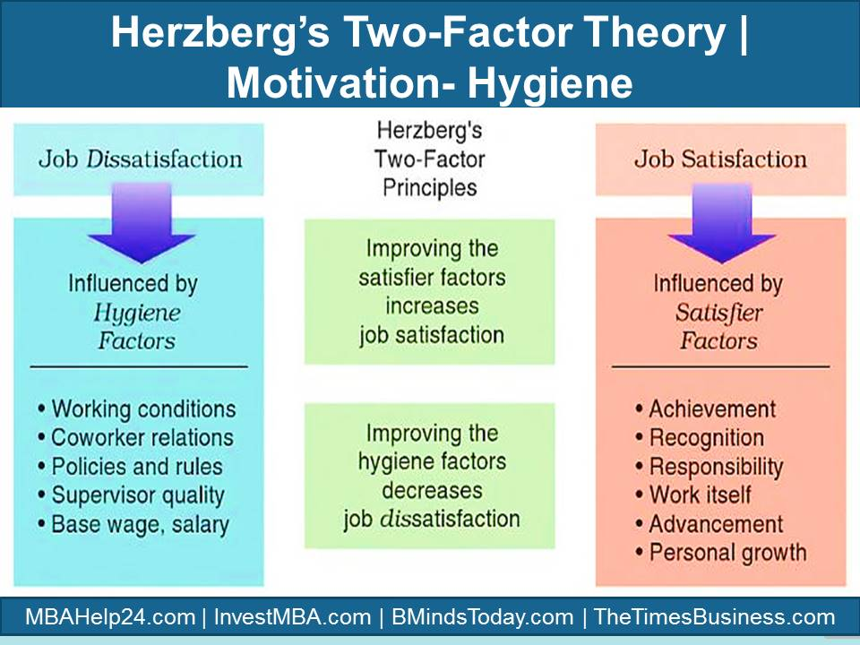
  + **By focusing only on hygiene factor the workers does not become satisfied, they simply become “not dissatisfied”**
  + PM can do:
    - Motivation
      * Provide learning of new skills, personal growth
      * Interesting and varied challenges
      * Provide appropriate responsibility
      * Tangible and objectively measurable results
      * Possibility to be promoted and recognized
    - Hygiene
      * Protect against inadequacy
      * Ensure effectiveness and direct supervision
      * Promote open and bilateral social interaction
      * Ensure that status is recognized (job title, private work space)
      * Provide clean and healthy physical work environment
      * Protect against instability
* 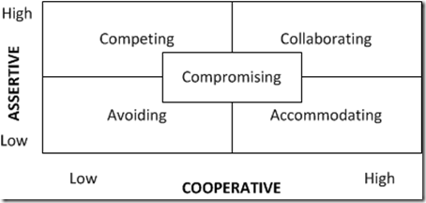
* Influence strategies
  + Give a reason
  + Friendliness
  + Consensus with others
  + Interpersonal (influence the others)
  + Directive
  + Hierarchical
* Negotiations strategies
  + Focus on the problem not the people
  + On interest not demands
  + New options
  + Fair

### Body language

* 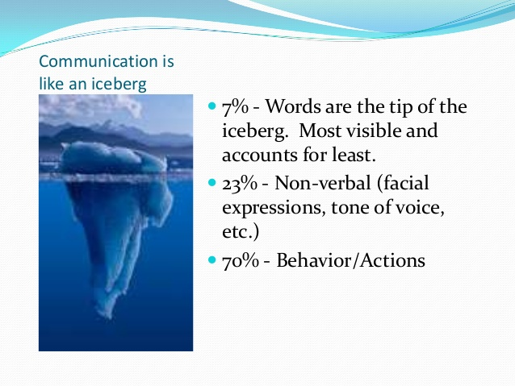
* 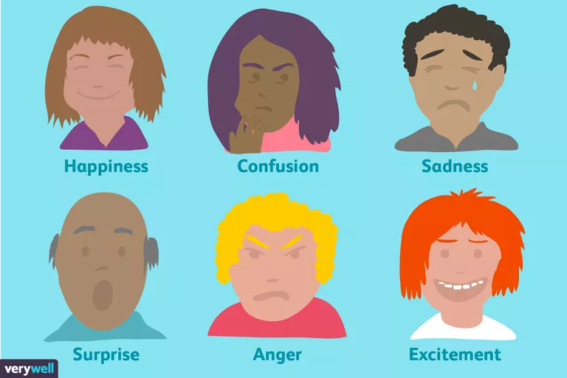
* **Crossed arms** might indicate that a person feels defensive, self-protective, or closed-off.
* **Standing with hands placed on the hips** can be an indication that a person is ready and in control, or it can also possibly be a sign of aggressiveness.
* **Clasping the hands** behind the back might indicate that a person is feeling bored, anxious, or even angry.
* **Rapidly tapping fingers or fidgeting** can be a sign that a person is bored, impatient, or frustrated.
* **Crossed legs** can indicate that a person is feeling closed off or in need of privacy.
* 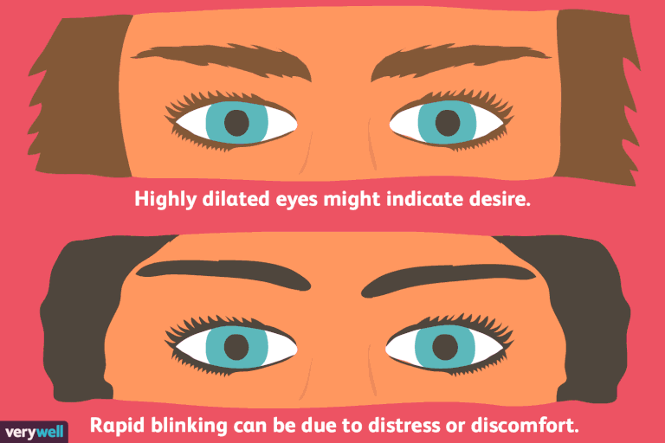

### Shannon-Weaver model

* 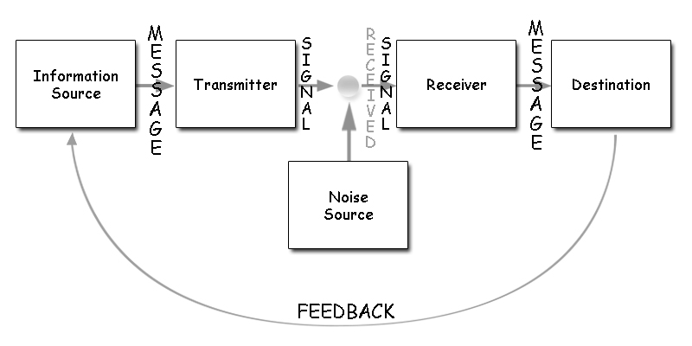

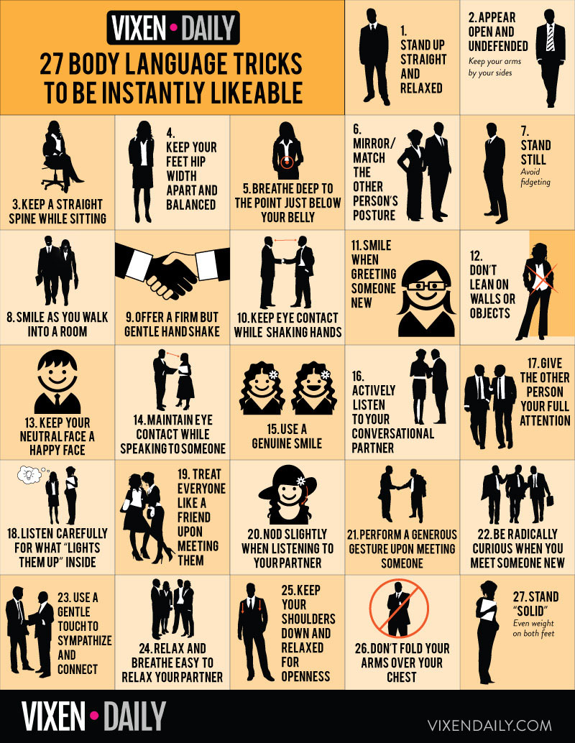

### Main causes of communication breakdown

* Bad communication skills
* Band intentions
* Climate of fear
* Cultural differences
* Different level of knowledge
* Lack of respect
* Lack of leadership
* Lack of trust
* Unclear agenda
* Unclear priorities
* Technical problems and misuderstanding

## Miscellaneous

* <http://www.sachinrekhi.com/a-lean-alternative-to-a-business-plan-documenting-your-product-market-fit-hypotheses>
  + Choose true audience (not just some big market)
  + RACI model (responsibilities and decision making)
  + Also about verbal communication (ask other about their lives and stuff like that)
  + **Decision based on the audience**
    - **Are we improving/developing this feature for this audience or other one?**
* 